🎯 Internship Hunt Bot — Concept
How it works end-to-end
You (Telegram) → Upload Resume PDF
↓
Bot parses resume → extracts skills, domain, experience level
↓
Background agent searches internship portals (LinkedIn, Internshala, Indeed, etc.)
↓
Filters & scores matches against your profile
↓
Auto-applies where possible (form fill / email)
↓
Tracks applications → sends follow-up reminders
↓
Reports back to you on Telegram daily
Components
Layer | Tool | Role
Chat interface | Telegram Bot | You interact, upload resume, get updates
AI brain | Claude API (via OpenClaw/n8n) | Parse resume, score jobs, draft cover letters
Job search | Web scraping / RapidAPI job feeds | Pull fresh listings from portals
Auto-apply | Playwright/Selenium | Fill and submit application forms
Follow-up | Scheduled Claude prompts | Draft follow-up emails after 5–7 days
Database | SQLite / Airtable | Track applied jobs, status, dates
Orchestration | n8n (open source) or Python scheduler | Glue everything together

Conversation flow in Telegram
Bot: "Hi! Send me your resume (PDF) to get started."
You: [uploads resume.pdf]
Bot: "Got it! Parsing your profile...
✅ Skills found: Python, DevOps, Jenkins, Linux
✅ Domain: IT Infrastructure / Cloud
✅ Level: Internship / Entry

Which portals should I search?
[LinkedIn] [Internshala] [Indeed] [All]"

You: All

Bot: "🔍 Searching... found 23 matches. Applying to top 10.
Progress updates every 2 hours."

--- 2 hours later ---
Bot: "📬 Applied to 8/10 so far:
✅ TechCorp - Cloud Intern
✅ Allianz Tech - DevOps Trainee
⏳ StartupXYZ - pending CAPTCHA

Follow-ups scheduled for Dec 13."
🏗️ Full Architecture — n8n + Telegram + Claude
System Overview
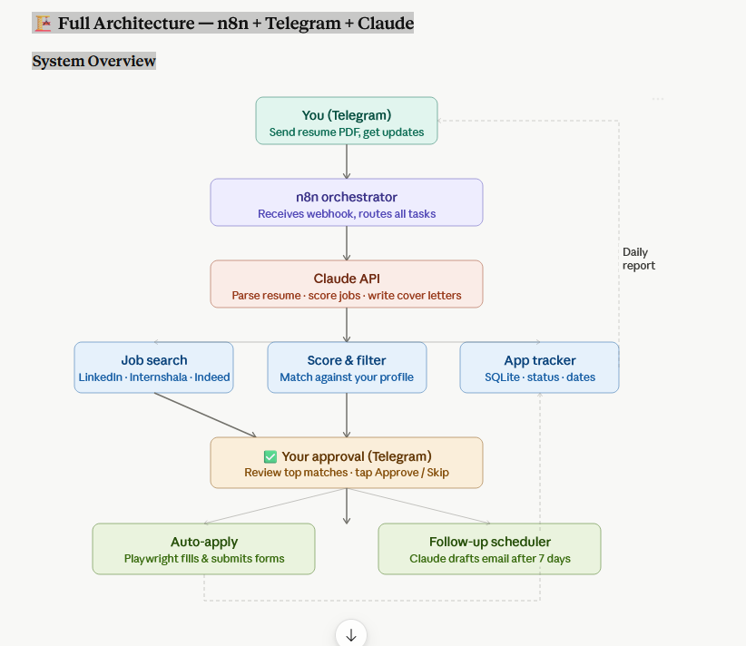
Phase 1 — Core bot (get it running in 1 day)
What you need:
- n8n installed locally or free cloud at n8n.io
- Telegram Bot token (from @BotFather — free, 2 minutes)
- Anthropic API key
- Python 3.10+ for the scraper script
n8n workflows to build:
Workflow 1 — Resume intake Telegram Trigger → Download PDF attachment → HTTP Request to Claude API (parse skills/domain/level) → Store result in n8n variables → Reply to Telegram with parsed profile
Workflow 2 — Job search (runs every 6 hours) Schedule Trigger → Python script node (scrape LinkedIn/Internshala via RapidAPI) → Claude API (score each job against stored profile) → Filter top 5 → Format message → Send to Telegram for approval
Workflow 3 — Approval handler Telegram Trigger (button callback) → If Approve → trigger Playwright apply script → Update SQLite tracker → If Skip → mark skipped in tracker
Phase 3 — Follow-up (add last)
n8n Schedule Trigger (daily) → Query SQLite for applications older than 7 days with no response → Claude API generates personalised follow-up email → Send via Gmail node → Log sent date in tracker → Notify you on Telegram.

Job portals you can tap without paying
Portal | Method
LinkedIn | RapidAPI LinkedIn Jobs Search (~free tier)
Internshala | Direct HTTP scrape (Python requests + BeautifulSoup)
Indeed | RapidAPI Indeed scraper
Naukri | Selenium/Playwright scrape
Wellfound (AngelList) | Public API

Want me to start building? I can generate the complete n8n workflow JSON + the Python scraper + Claude prompt templates as a ready-to-import package. Just confirm:
- Are you running n8n locally or on n8n cloud?
- Which job portals matter most to you — IT/DevOps internships specifically?
- nternship Hunt Bot — n8n workflow
- 30 nodes · 3 triggers · multi-AI provider · ready to import
- 30
- Nodes
- 3
- Triggers
- 5
- AI calls
- 7
- Telegram msgs
- Triggers (3)
- Telegram messages (7)
- AI calls — swap provider via env vars (5)
- Logic & code (8)
- HTTP / API (3)
You have 3 ways to get the file — the Download button in the viewer above, the file attachment just above this, or copy the raw JSON from the "Raw JSON" tab.
To import into n8n (3 steps):
- Open n8n → Workflows → click the ... menu → Import from file → select the JSON
- Go to Settings → Variables and add these 4 env vars:
Variable | Example value
AI_BASE_URL | https://api.anthropic.com/v1 (or OpenAI/Grok URL)
AI_API_KEY | your key
AI_MODEL | claude-sonnet-4-6 or gpt-4o or grok-3
RAPIDAPI_KEY | from rapidapi.com → search JSearch (free tier)
- Add a Telegram credential named exactly Telegram Bot with your @BotFather token → Activate workflow → Send your resume PDF to the bot.
Switching AI provider — only those 3 env vars. All 5 AI nodes share them, so changing once affects everything. Works with any OpenAI-compatible endpoint including Ollama locally.

